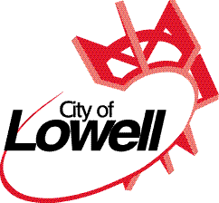
301 East Main Street
Lowell, Michigan 49331
Phone (616) 897-8457
Fax (616) 897-4085

CITY OF LOWELL

PUBLIC NOTICE

Please take notice that the Lowell City Council will hold a public hearing on Monday, August 3, 2019 at 7:00 pm., in the City Hall at 301 East Main Street, Lowell, Michigan. The subject of the hearing will be:
Request for an amendment to the Planned Unit Development at 219 High Street called “Riverview Flats.”

Unity School Investors, LLC, has submitted an application to amend the Riverview Flats Planned Unit Development (PUD) at 219 High Street. Proposed amendments to the PUD include a reoriented driveway, modified project boundary, additional parking, and related changes to the site layout.

Copies of the proposed PUD, supporting documentation and materials, and the City’s Zoning Ordinance are available for public viewing during regular business hours at Lowell City Hall, 301 East Main Street, Lowell, Michigan. Written Comments will be received until the night of the hearing.

If you are planning to attend this hearing and are handicapped requiring any special assistance, please notify the City Clerk by calling at (616) 897-8457 as soon as possible.

Respectfully,

Susan Ullery
City Clerk

